(Your Organization Name) Community Member Schedule Request Guide

Register an FMX Account

Step 1: Open an internet browser and navigate to (yourfmxsite.gofmx.com/register).
Step 2: Fill out the community member registration form. (Please note fields with an asterisk are required.)
Step 3: After filling out the form you will be sent an email with a confirmation link. Simply click the link to confirm your account and log in.

Login to FMX

Step 1: Open an internet browser and navigate to (yourfmxsite.gofmx.com)
Step 2: Log in with the email address and password you selected earlier.

Create a Schedule Request

Step 1: Click Schedule Requests in the left sidebar, then click New request.

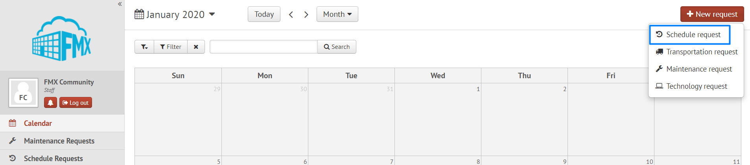

Step 2: Enter the required fields (marked with an asterisk) and click Submit to submit the schedule request (see picture below).
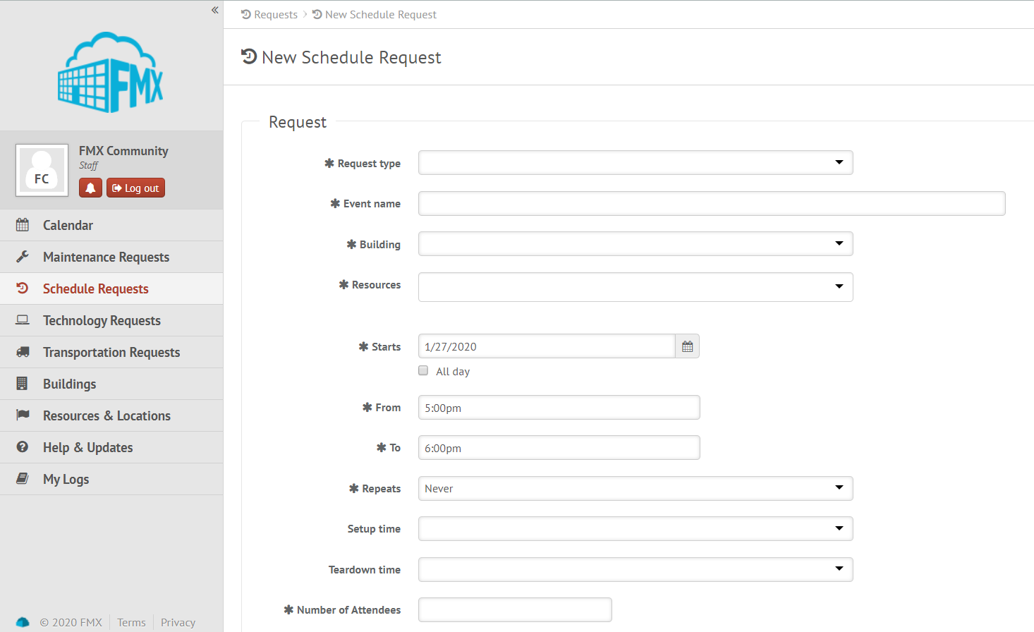

Step 3: Check your email for your request confirmation and a link to check the status of your request. New requests will have a “Pending” status until they have been approved by the Principal and the Facilities Department.

Edit a Schedule Request

Step 1: Find the schedule request you wish to edit (on the calendar or in the schedule requests grid), then click the Edit icon (from the grid) or click on the request and then click the Edit icon (from the calendar, see picture below).

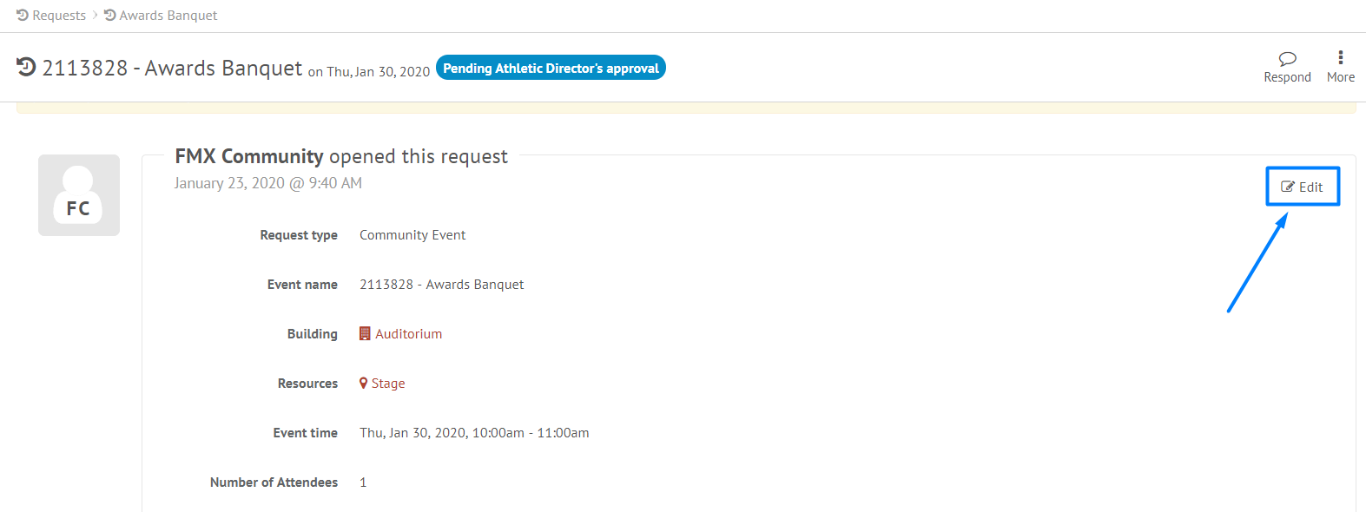

Step 2: After making the necessary editing changes click Save.

Respond to a Schedule Request

Step 1: Find the schedule request you wish to respond to (on the calendar or in the schedule requests grid), then click Respond.
Step 2: Enter a response.

Step 3: Click Respond to send your response. This will generate an email notification to all users involved with the request.

