(Your Organization) FMX Administrator Work Request Guide

Login to FMX

Step 1: Open an internet browser and navigate to (youfmxsite.gofmx.com)
Step 2: Log in with the following credentials:
- Email
- Password

Create a Request (Shortcut)

Step 1: Click New request in the right top corner of the calendar page.
Step 2: Choose the request type you would like to submit from the drop down list (see picture below).

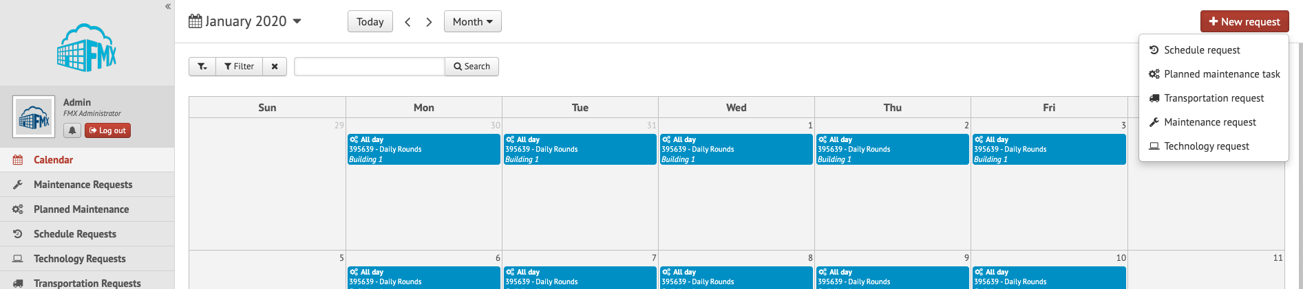

Create a Maintenance, Technology, or Custom Work Request

Step 1: Click Maintenance, Technology, or Planning Request in the left sidebar, then click New Maintenance (Technology or Planning) request.
Step 2: Enter the required fields and click Submit to submit the maintenance request (see picture below).

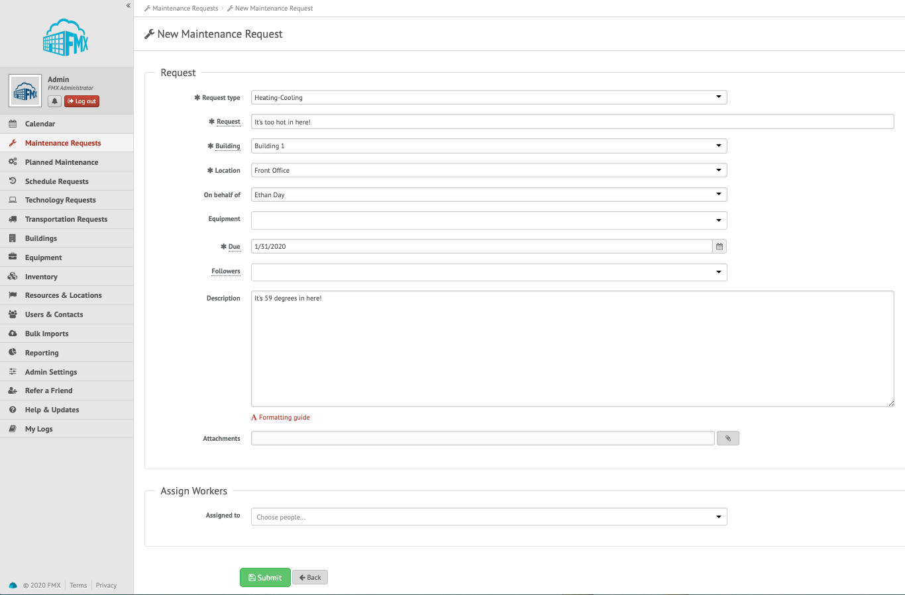

Step 3: Check your email for your request confirmation and a link to check the status of your request.
Step 4: When your request is resolved you will receive a “request resolved” email

Edit a Maintenance, Technology, or Custom Work Request

Step 1: Find the Maintenance, Technology, or Custom Work Request you wish to edit (on the calendar or in the requests grid), then click the Edit icon (from the grid) or click on the request and then the Edit icon (from the calendar, see picture below)
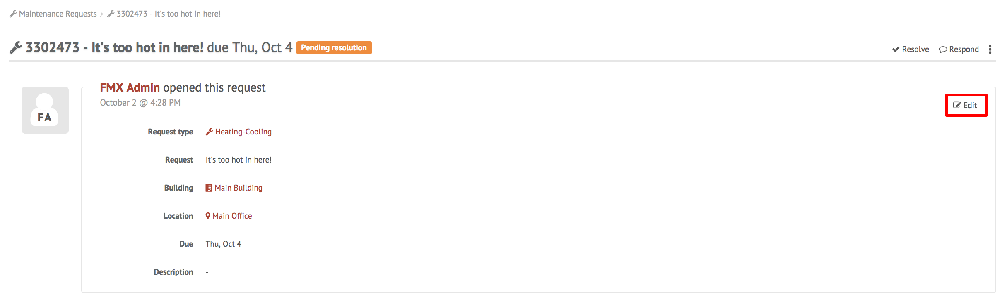

Step 2: After making the necessary editing changes click Save.

Approve or Decline a Maintenance, Technology, or Custom Work Request

Step 1: Find the request you wish to approve or decline in FMX (on the calendar or in the requests grid accessed via the left sidebar), then click Approve or Decline.
Step 2: Accept or decline the request - To Approve: click Approve, then click Approve again to confirm.

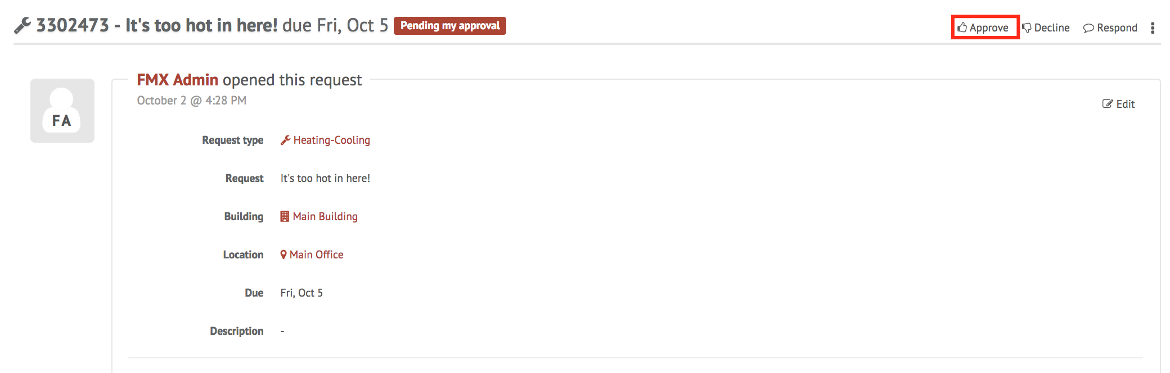

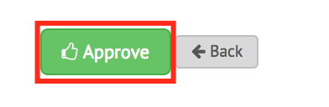

To Decline: click Decline, enter reason and click Decline again to confirm.

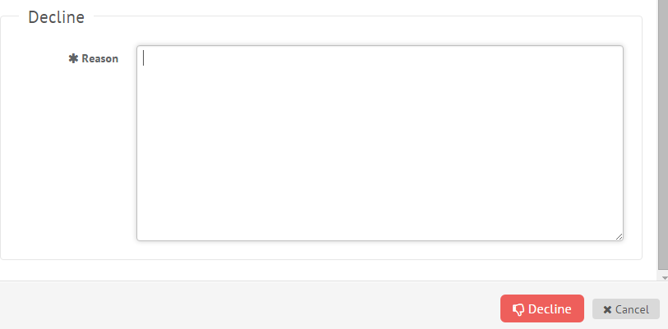

Assign a Maintenance, Technology, or Custom Work Request

Step 1: Find the request you wish to assign (on the calendar or in the maintenance requests grid), then click Assign.
Step 2: Select which user(s), equipment, and/or request type to assign the request to and select a vendor if the request will be outsourced (see picture below).

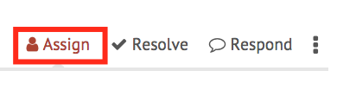
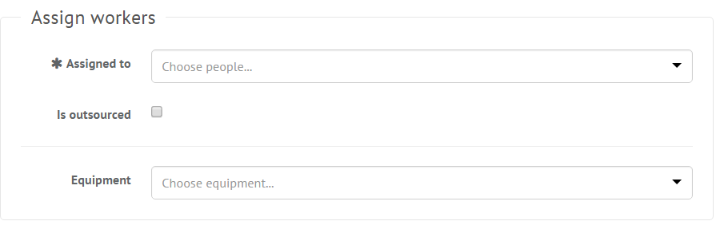

Step 3: Click Assign and the assigned user(s) will receive an email indicating that they have been assigned to the request.

Respond to a Maintenance, Technology, or Custom Work Request

Step 1: Find the request you wish to respond to (on the calendar or in the requests grid), then click Respond.
Step 2: Enter a response.

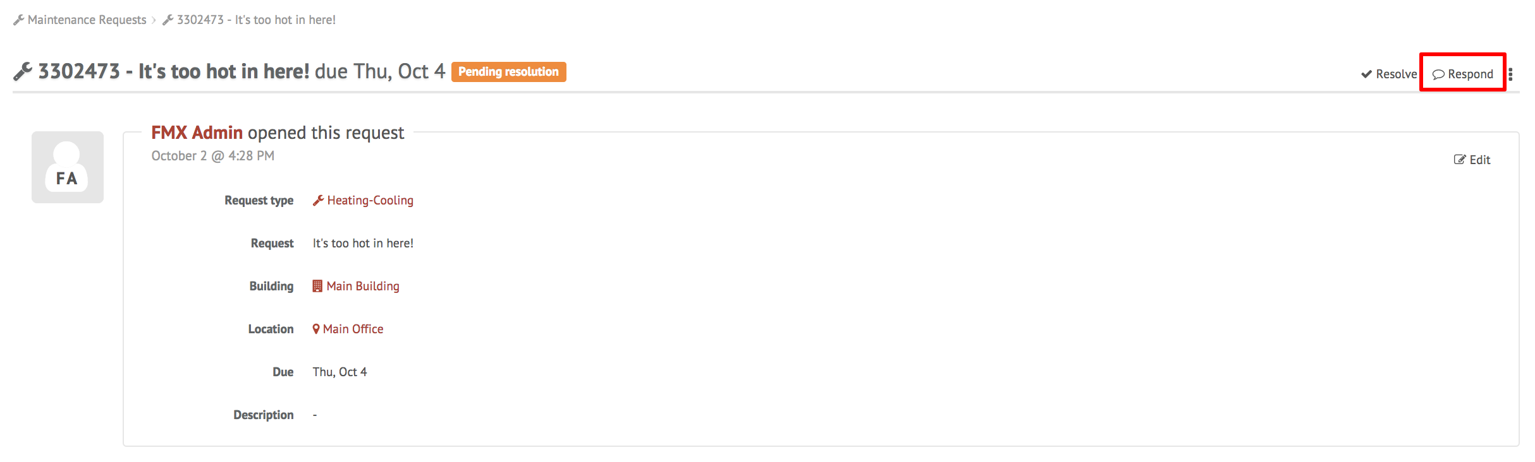

Step 3: Click Respond to send your response.

Resolve a Maintenance, Technology, or Custom Work Request

Step 1: Find the request you wish to resolve (on the calendar or in the requests grid), then click Resolve.
Step 2: After clicking Resolve you can enter a resolution, hours, cost, equipment and attach an invoice (see picture below).

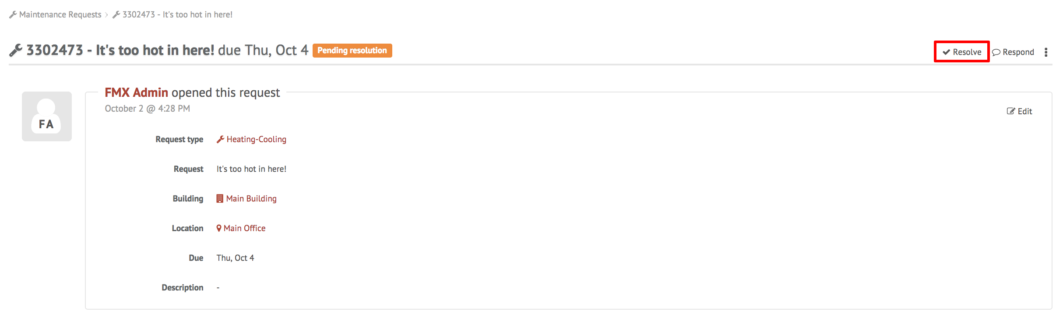
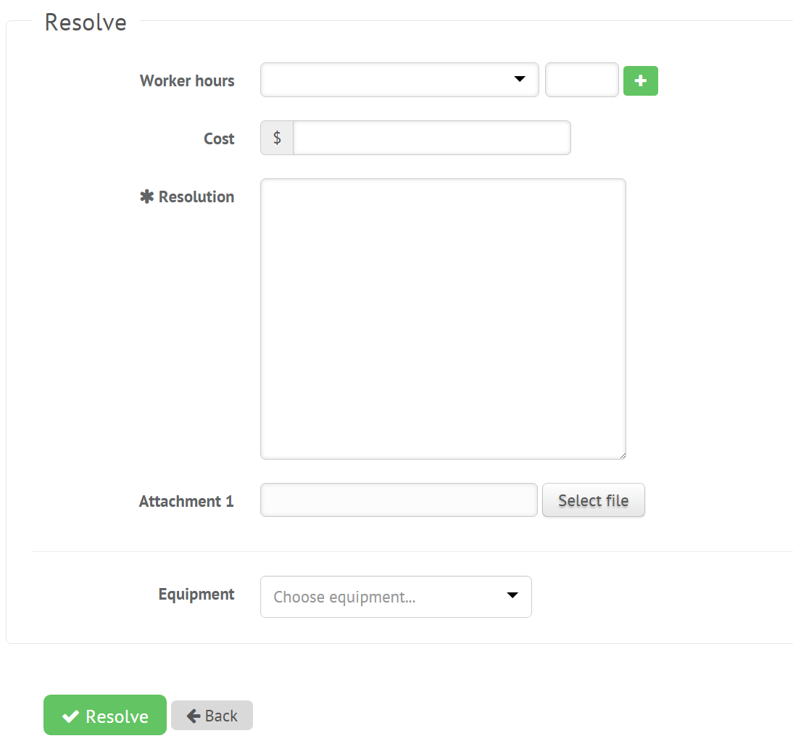

Step 3: Click Resolve to close the maintenance request.

Filter in Calendar View
Step 1: Click the Filter button above the calendar view and select the filter you would like:
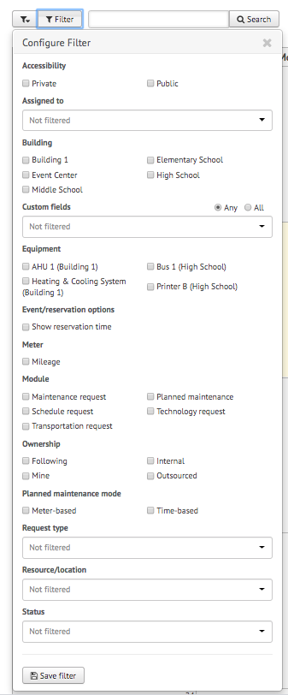
NOTE: You may choose more than one filter at a time

Remove Filters
If you're having trouble locating certain requests, events, or other information on your FMX calendar or in your FMX grids it could be because you have a filter selected that is hiding the information you're looking for.
You can see the filters that have been applied by looking underneath the Filter and Search bar:
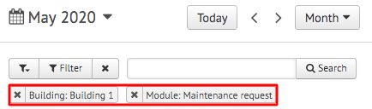

Remove All Filters
To quickly remove all of the filters that are currently selected, click on the "x" attached to the filter button:
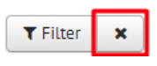

Another way to remove filters is to click on the "Filter" button and choose "Clear Filter" at the bottom of the page:
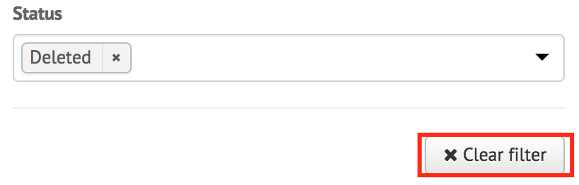

Remove a Single Filter
To remove filters one at a time, click on the "x" button next to the filter(s) you would like to remove:
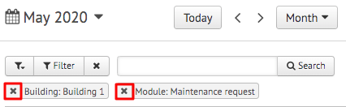

Save Filters
To save your current filters for future use, click the button at the bottom that says "Save Filter":
Then type in the name of this saved filter. Once done, click the checkmark to save:
