(Your Organization) FMX Administrator Transportation Request Guide

Login to FMX

Step 1: Open an internet browser and navigate to (your organization URL).
Step 2: Log in with the following credentials:
- Email
- Password

Create a Request

Step 1: On the calendar page, click New Request on the top right side of the page, then select Transportation Request.

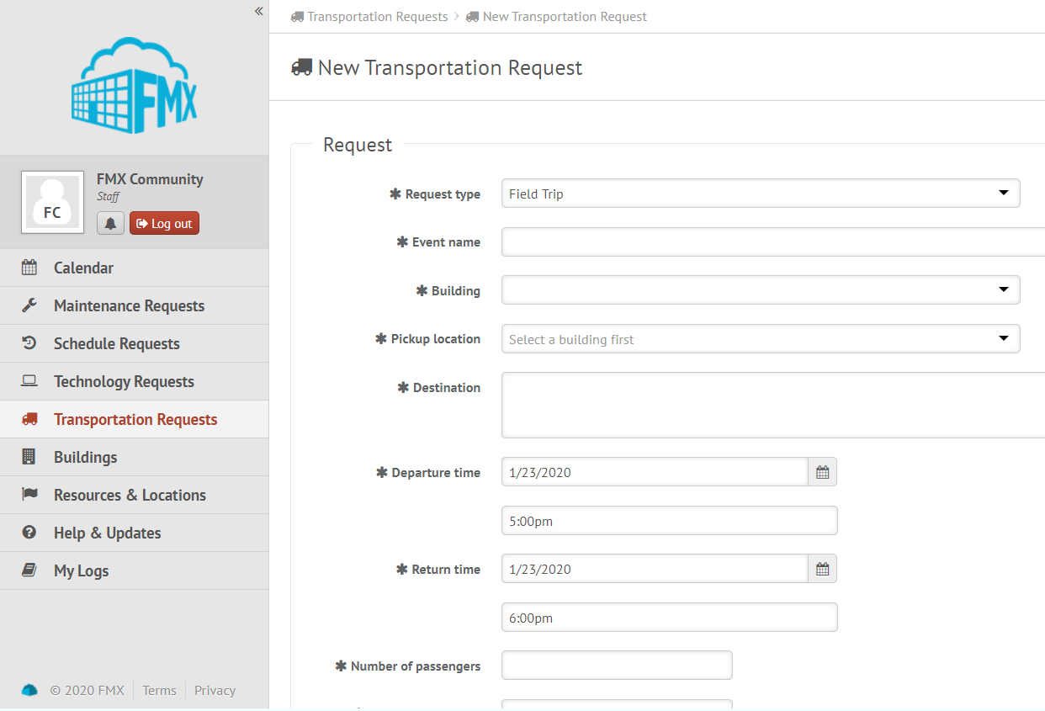

Step 2: Enter the information on the request form. Note: items marked with an asterisk are required. Click Save at the bottom to submit your request.

Edit a Transportation Request

Step 1: Find the transportation request you wish to edit (on the calendar or in the transportation requests grid), then click Details (from the grid) or click More info and then Details (from the calendar, see picture below).

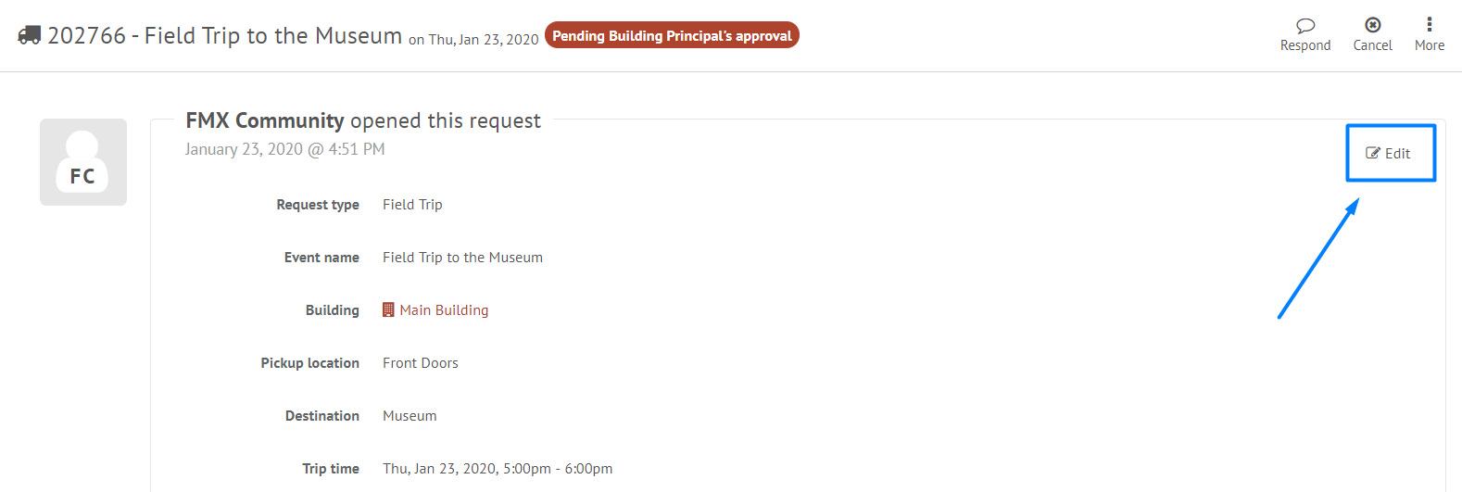

Step 2: After making the necessary editing changes click Save.

Respond to a Transportation Request

Step 1: Find the request you wish to respond to (on the calendar or in the transportation requests grid accessed via the left sidebar), double click to open the request, then click Respond.
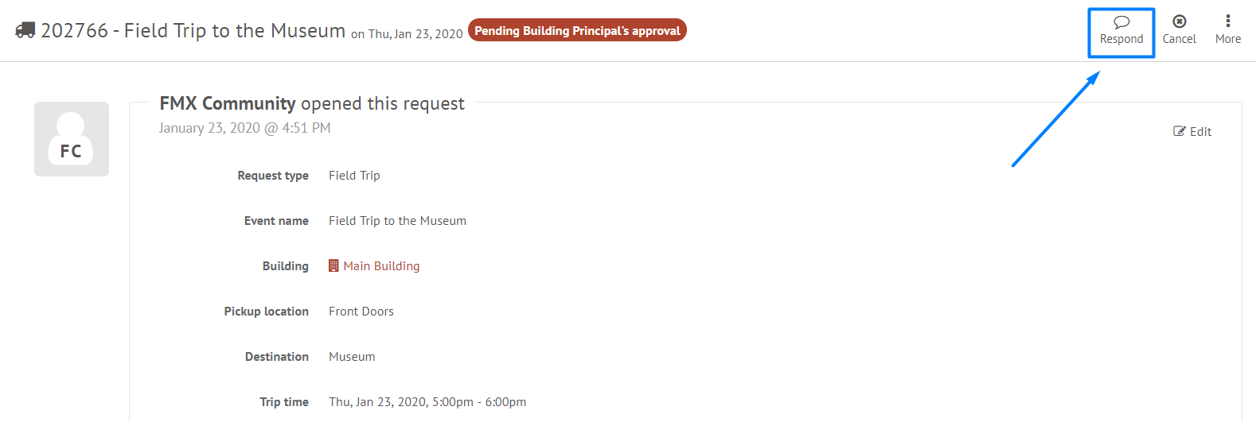

Step 2: Type your response.

Step 3: Click Respond to send your response. This will generate an email notification to all users involved with the request.

Approve a Transportation Request

Step 1: Find the transportation request you wish to approve (on the calendar or in the transportation requests grid), then click Approve (see picture below).
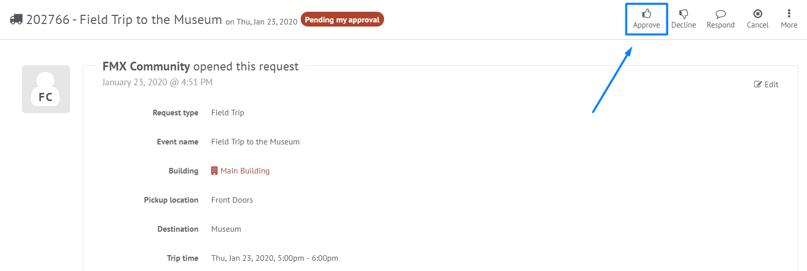

Step 2: Click Approve again to finalize the approval.

Decline a Transportation Request

Step 1: Find the transportation request you wish to approve (on the calendar or in the transportation requests grid), then click Decline (see picture below).
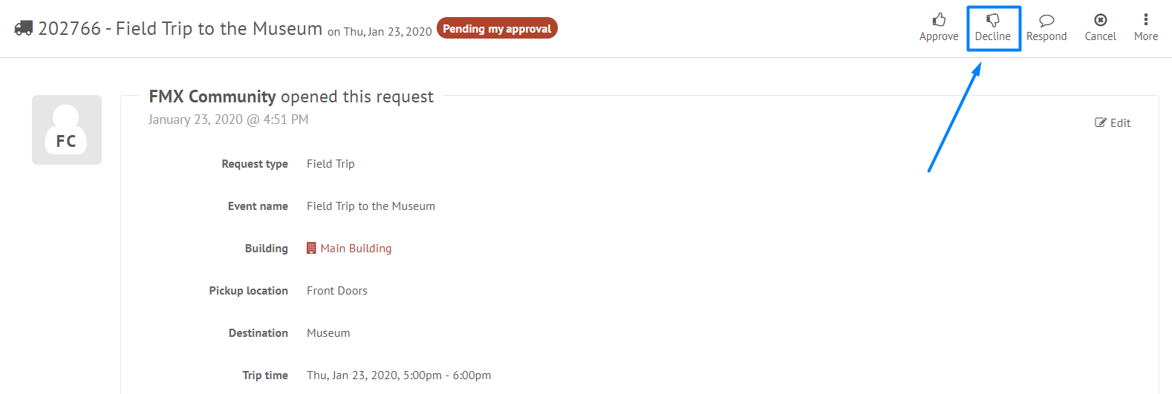

Step 2: Enter a reason for declining and click Decline again to finalize the declination.

Assigning a Vehicle or Driver to a Transportation Request

Step 1: Find the transportation request you wish to assign (on the calendar or in the transportation requests grid accessed via the left sidebar).

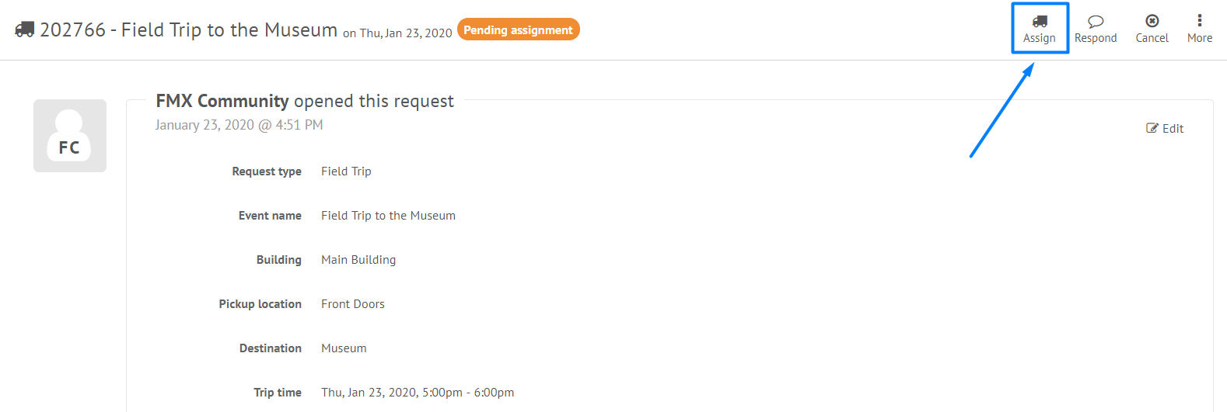

Step 2: Click Assign Vehicle to select a vehicle, then click Save.

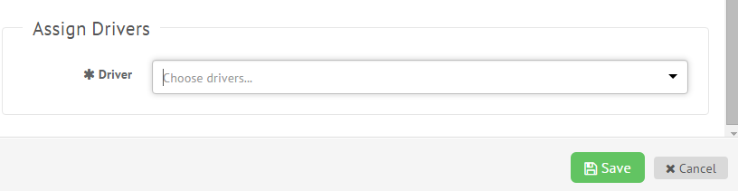

Finalizing a Transportation Request

Step 1: Find the transportation request you wish to finalize (on the calendar or in the transportation requests grid), then click Finalize (see picture below).
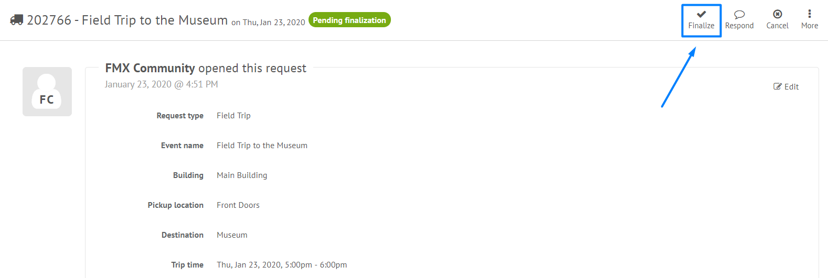

Step 2: Enter finalized departure date/time, return date/time, departure mileage and return mileage. Click Finalize to finalize the trip.

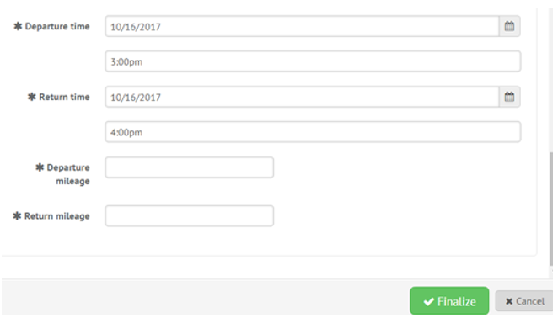

Filter in Calendar View
Step 1: Click the Filter button above the calendar view and select the filter you would like:
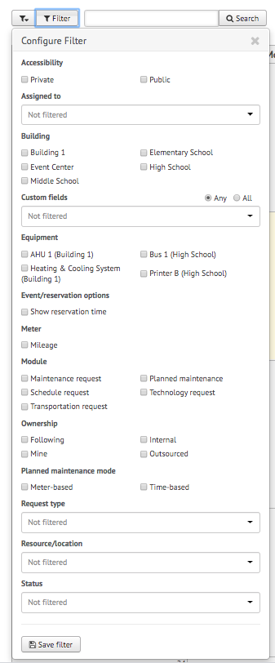
NOTE: You may choose more than one filter at a time
Remove Filters
If you're having trouble locating certain requests, events, or other information on your FMX calendar or in your FMX grids it could be because you have a filter selected that is hiding the information you're looking for.
You can see the filters that have been applied by looking underneath the Filter and Search bar:
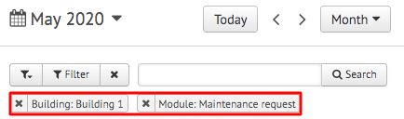

Remove All Filters
To quickly remove all of the filters that are currently selected, click on the "x" attached to the filter button:
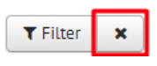

Another way to remove filters is to click on the "Filter" button and choose "Clear Filter" at the bottom of the page:
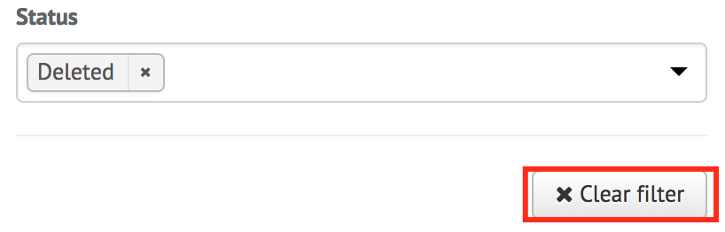

Remove a Single Filter
To remove filters one at a time, click on the "x" button next to the filter(s) you would like to remove:
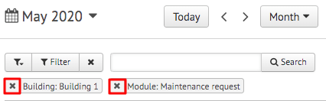

Save Filters
To save your current filters for future use, click the button at the bottom that says "Save Filter":
Then type in the name of this saved filter. Once done, click the checkmark to save:
