(Your Organization) FMX Administrator Planned Maintenance Guide

Login to FMX

Step 1: Open an internet browser and navigate to (yourcompany.gofmx.com)
Step 2: Log in with the following credentials:
- Email
- Password

Create an Instruction Set

Step 1: Select Planned Maintenance in the left sidebar, then click on the Instruction Sets tab.
Step 2: Click on the +New instruction set button.
Step 3: Enter the instruction set name - this will be the name for the step-by-step checklist (e.g., HVAC Monthly PM, Check Belt Tension)
Step 4: Enter the description (optional) - this is where you can describe what the instruction set will be used for.
Step 5: Add custom fields if you would like the resolving user to capture additional information when completing the task (ex. Temperature).
Step 6: Add any additional attachments corresponding with the planned maintenance instructions
Step 7: Enter your list of steps for the planned maintenance.

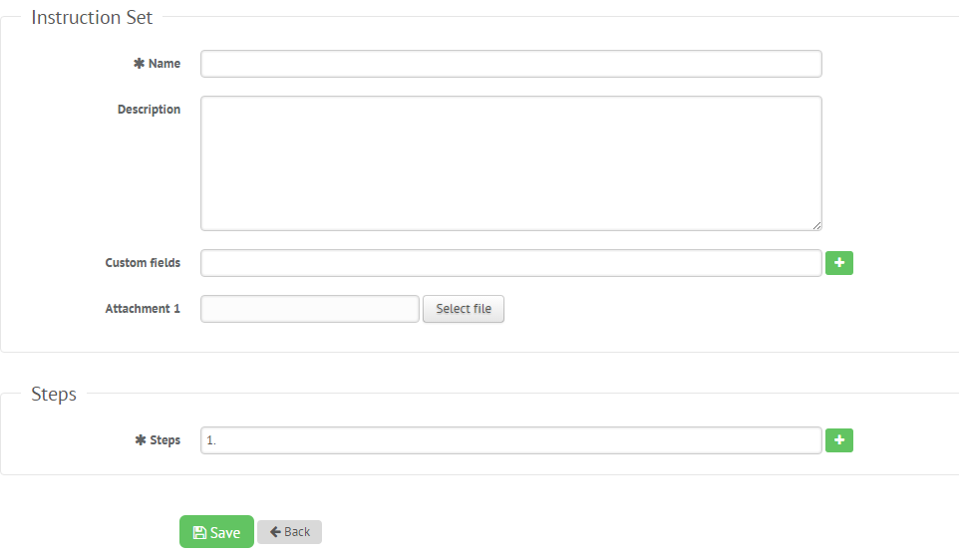

Step 8: Select Save to add the instruction set.

Create a Planned Maintenance Task

Step 1: On the calendar page, click New Request on the top right side of the page, then select Planned Maintenance Task.
Step 2: Enter the name of the task (e.g. AHU #1 Quarterly PM, Check Belt Tension – Monthly).
Step 3: Enter the date of first time the task will occur.
Step 4: Enter the frequency of the task occurrence (Daily, Weekly, Monthly, Yearly), then select how often you want it to occur. If the task should not occur during part of the year, enter the date range in the Exclusion date section (e.g. landscaping tasks that will not occur during the winter months). Finally, select whether you want the next due date to be fixed based on the due date or vary based on the last execution date.
Step 5: Add any additional attachments you need for the task.
Step 6: Enter the name of the Instruction Set that you created in the Instruction Sets. If no instruction set is required for the task then leave this blank.
Step 7: This is the building where the task will take place.
Step 8: Enter equipment. Leave blank if the task is not associated with equipment. If you want to associate the task with equipment, this is where you would add the Equipment Tag (e.g., AHU # 1, Exhaust Fan 12, Fire Extinguisher).
Step 9: Select the name of the person you wish to assign to this task.
Step 10: Check the box is the task if outsourced.
Step 11: Set up optional email reminders if you would like reminders to be sent before the task is due or after it has become overdue.
Step 12: Click Save to add the planned maintenance task to your FMX calendar.
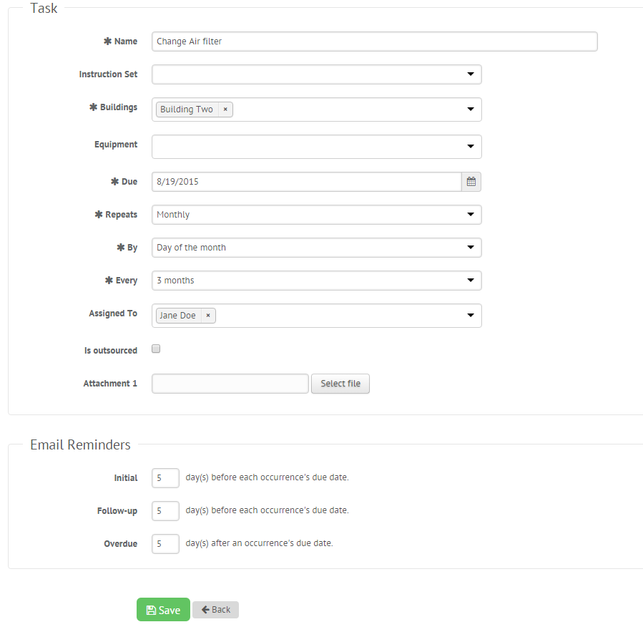

Respond to a Planned Maintenance Task

Step 1: Find the task you wish to respond to (on the calendar or in the planned maintenance grid accessed via the left sidebar), and click Respond.
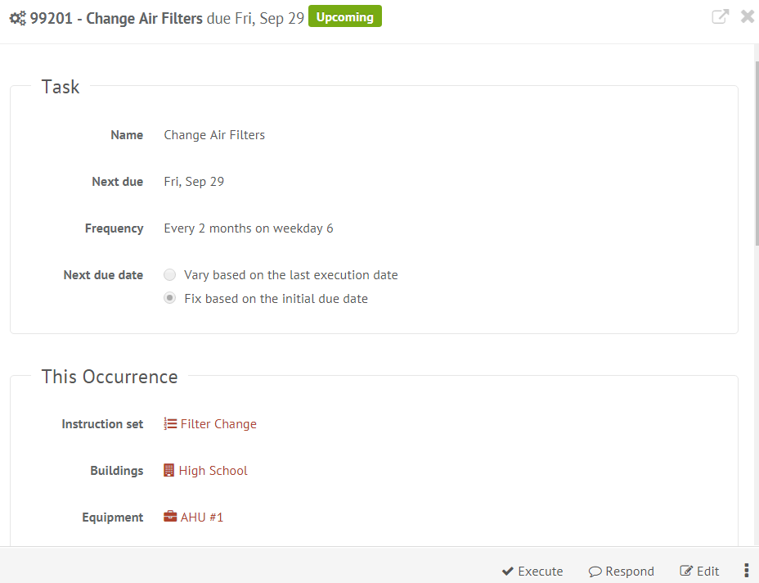

Step 2: Type response and click Respond.

Execute a Planned Maintenance Task

Step 1: Find the task you wish to execute (on the calendar or in the planned maintenance grid accessed via the left sidebar) then click Execute.
Step 2: Check off all steps of the instruction set (if there is one), enter a resolution, hours, cost, inventory and attach additional information if necessary.
Step 3: Click Execute to close out the task, or Save to complete the task later.
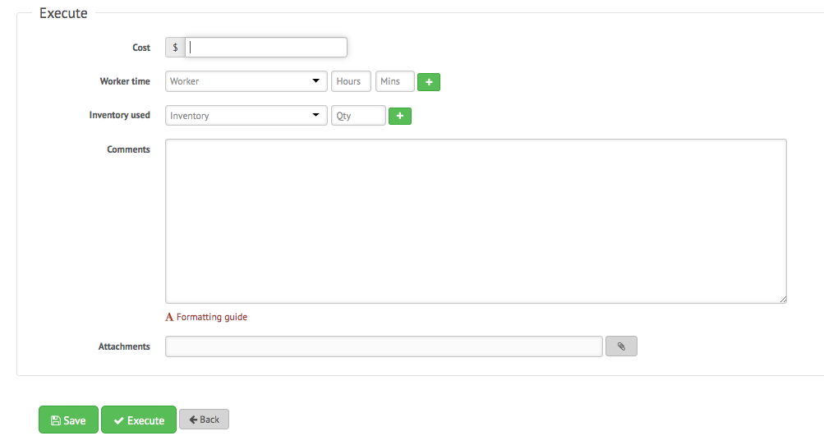

Reopen a Planned Maintenance Task

Step 1: Find the executed task you wish to reopen (on the calendar or in the planned maintenance grid accessed via the left sidebar) then click Reopen.
Step 2: Next, enter a reason for reopening the task and click Save.
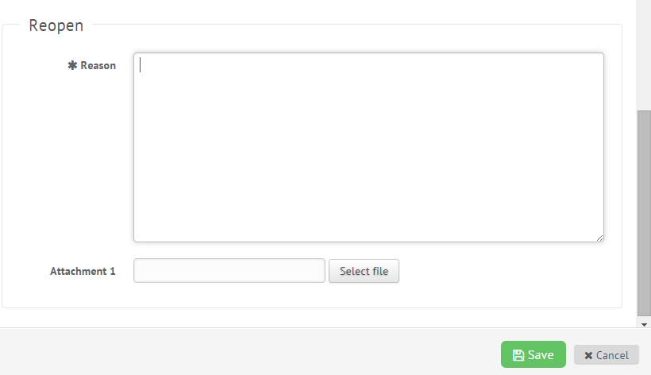
Filter in Calendar View
Step 1: Click the Filter button above the calendar view and select the filter you would like:
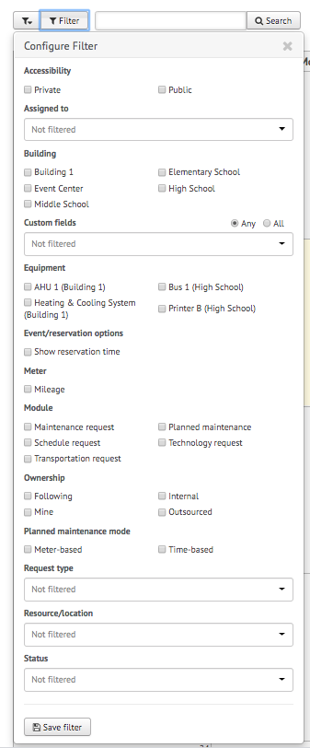
NOTE: You may choose more than one filter at a time
Remove Filters
If you're having trouble locating certain requests, events, or other information on your FMX calendar or in your FMX grids it could be because you have a filter selected that is hiding the information you're looking for.
You can see the filters that have been applied by looking underneath the Filter and Search bar:
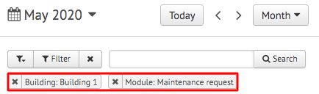

Remove All Filters
To quickly remove all of the filters that are currently selected, click on the "x" attached to the filter button:
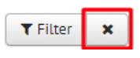

Another way to remove filters is to click on the "Filter" button and choose "Clear Filter" at the bottom of the page:
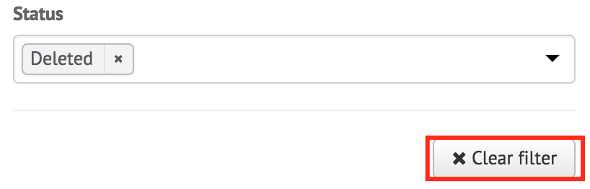

Remove a Single Filter
To remove filters one at a time, click on the "x" button next to the filter(s) you would like to remove:
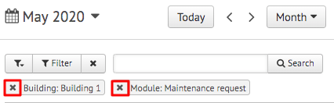

Save Filters
To save your current filters for future use, click the button at the bottom that says "Save Filter":
Then type in the name of this saved filter. Once done, click the checkmark to save:
