(Your Organization Name) Requester Schedule Request Guide

Login to FMX

Step 1: Open an internet browser and navigate to (yourfmxsite.gofmx.com)
Step 2: Log in with the following credentials:
- Email
- Password

Create a Request (Shortcut)

Step 1: Click New request in the right top corner of the calendar page.
Step 2: Choose the request type you would like to submit from the drop down list (see picture below).

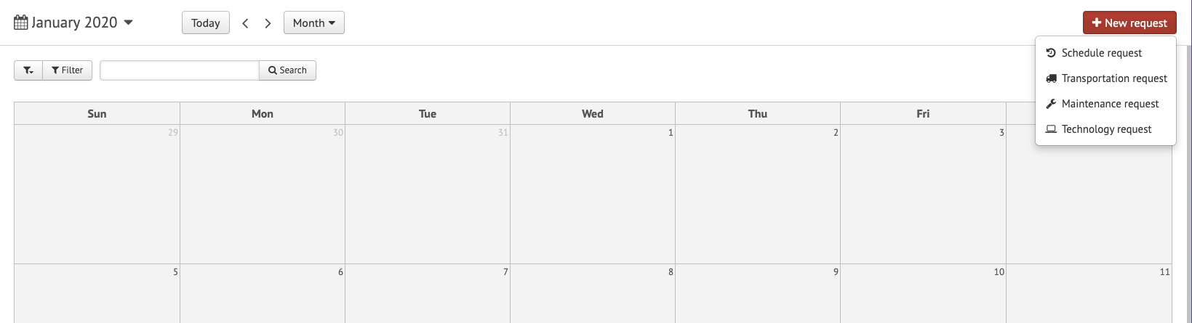

Create a Schedule Request

Step 1: Click Schedule Requests in the left sidebar, then click New request.

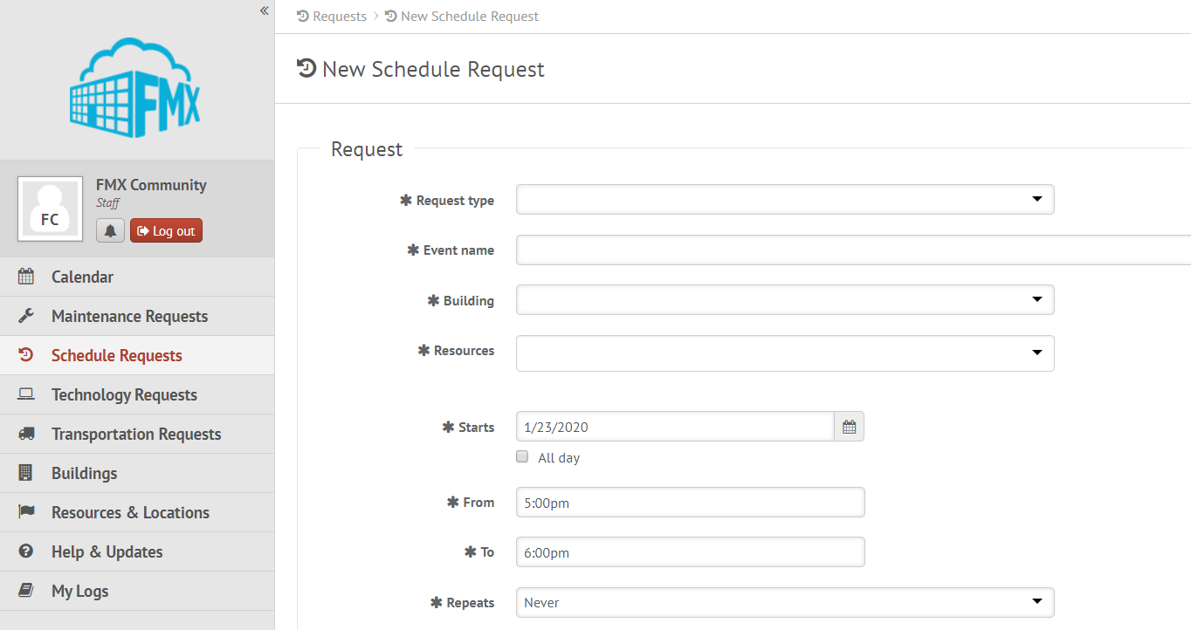

Step 2: Enter the required fields (marked with an asterisk) and click Submit to submit the schedule request.
Step 3: Check your email for your request confirmation and a link to check the status of your request. New requests will either be finalized or move on to a “Pending” state if they will be approved.

Edit a Schedule Request

Step 1: Find the schedule request you wish to edit (on the calendar or in the schedule requests grid), then click the Edit icon (from the grid) or click on the request and then click the Edit icon (from the calendar, see picture below).

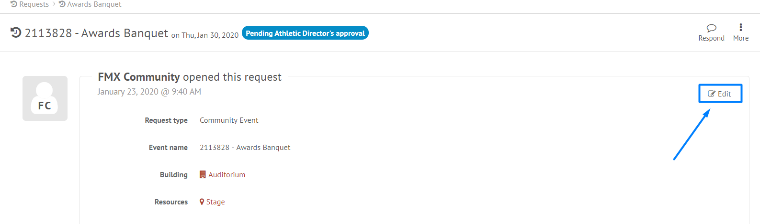

Step 2: After making the necessary editing changes click Save.

Respond to a Schedule Request

Step 1: Find the schedule request you wish to respond to (on the calendar or in the schedule requests grid), then click Respond.
Step 2: Enter a response (see picture below).
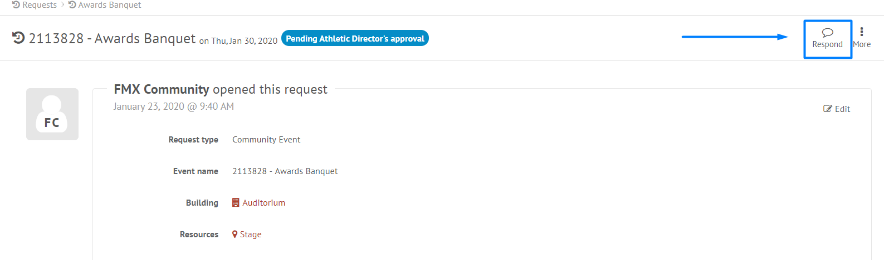

Step 3: Click Respond to send your response. This will generate an email notification to all users involved with the request.

Filter in Calendar View
Step 1: Click the Filter button above the calendar view and select the filter you would like:
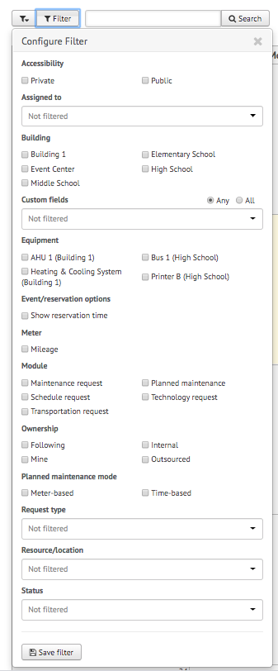
NOTE: You may choose more than one filter at a time
Remove Filters
If you're having trouble locating certain requests, events, or other information on your FMX calendar or in your FMX grids it could be because you have a filter selected that is hiding the information you're looking for.
You can see the filters that have been applied by looking underneath the Filter and Search bar:
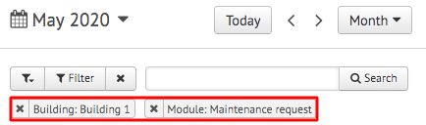

Remove All Filters
To quickly remove all of the filters that are currently selected, click on the "x" attached to the filter button:
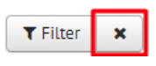

Another way to remove filters is to click on the "Filter" button and choose "Clear Filter" at the bottom of the page:
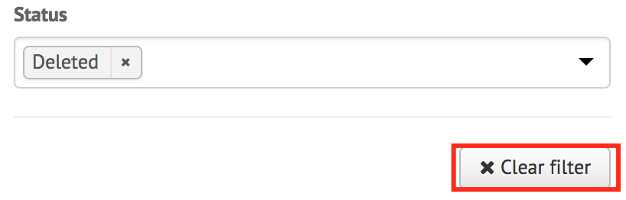

Remove a Single Filter
To remove filters one at a time, click on the "x" button next to the filter(s) you would like to remove:
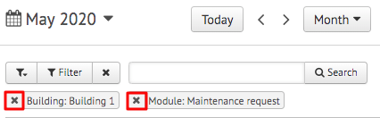

Save Filters
To save your current filters for future use, click the button at the bottom that says "Save Filter":
Then type in the name of this saved filter. Once done, click the checkmark to save:
