(Your Organization Approver) FMX Administrator Schedule Request Guide

Login to FMX

Step 1: Open an internet browser and navigate to (yourfmxsite.gofmx.com).

Step 2: Log in with the following credentials:
- Email
- Password

Create a Request (Shortcut)

Step 1: Click New request in the right top corner of the calendar page.

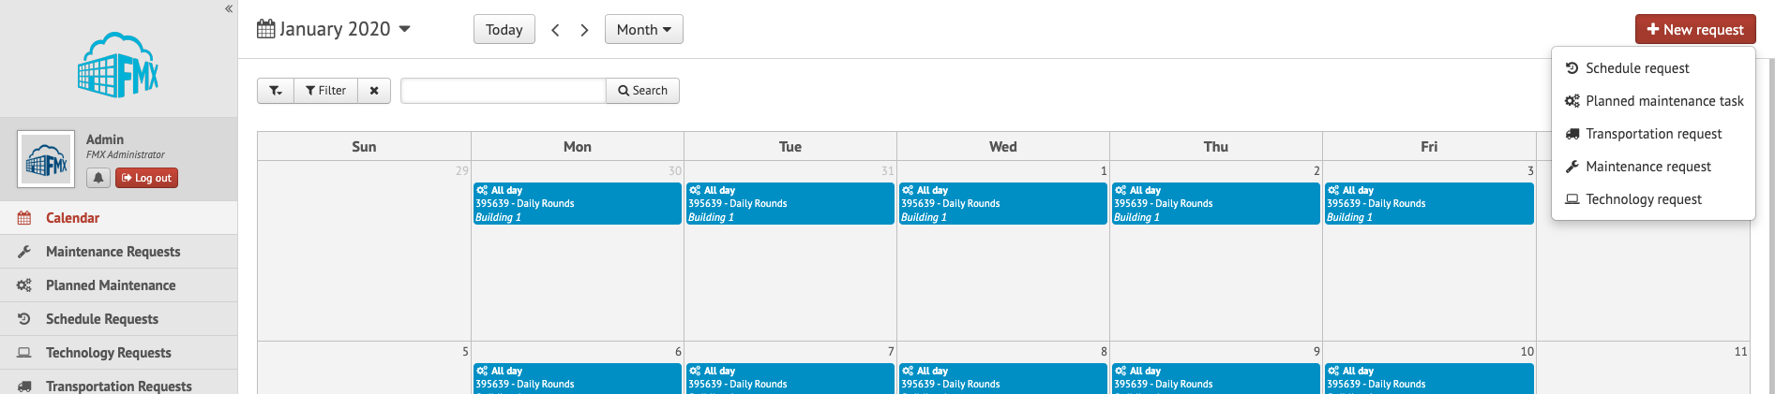

Step 2: Choose the request type you would like to submit from the drop down list (see picture below).

Create a Schedule Request

Step 1: Click Schedule Requests in the left sidebar, then click New request.

Step 2: Enter the required fields (marked with an asterisk) and click Submit to submit the schedule request (see picture below).

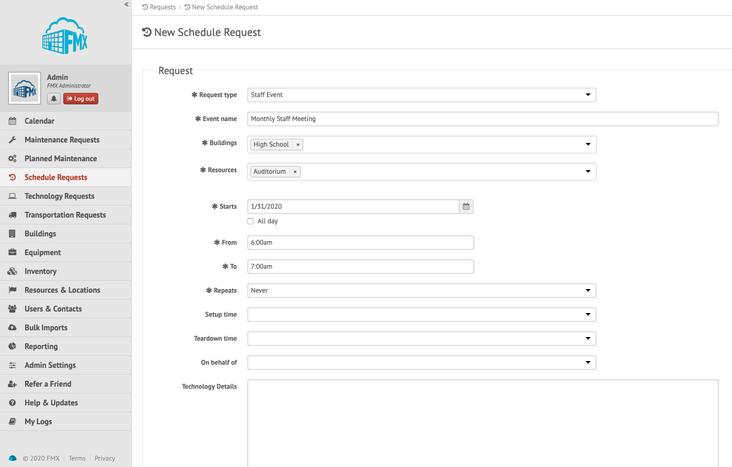

Step 3: Check your email for your request confirmation and a link to check the status of your request. New requests will have a “Pending” status until they have been approved.

Edit a Schedule Request

Step 1: Find the schedule request you wish to edit (on the calendar or in the schedule requests grid), then click the Edit icon (from the grid) or click on the request and then the Edit button:

Step 2: After making the necessary editing changes click Save.

Respond to a Schedule Request

Step 1: Find the schedule request you wish to respond to (on the calendar or in the schedule requests grid), then click Respond.

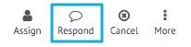

Step 2: Enter a response (see picture below).

Step 3: Click Respond to send your response. This will generate an email notification to all users involved with the request.

Approve a Schedule Request

Step 1: Find the schedule request you wish to approve (on the calendar or in the schedule requests grid), then click Approve (see picture below).

Step 2: Click Approve again to finalize the approval.

Decline a Schedule Request

Step 1: Find the schedule request you wish to approve (on the calendar or in the schedule requests grid), then click Decline (see picture below).

Step 2: Enter a reason for declining and click Decline again to finalize the declination.

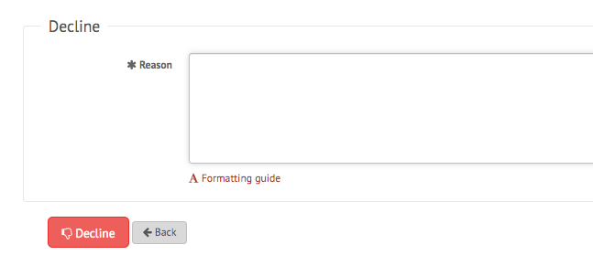

Estimate a Schedule Request (Skip this portion if you are not responsible for estimating)

Step 1: Find the schedule request you wish to estimate (on the calendar or in the schedule requests grid), then click Estimate.
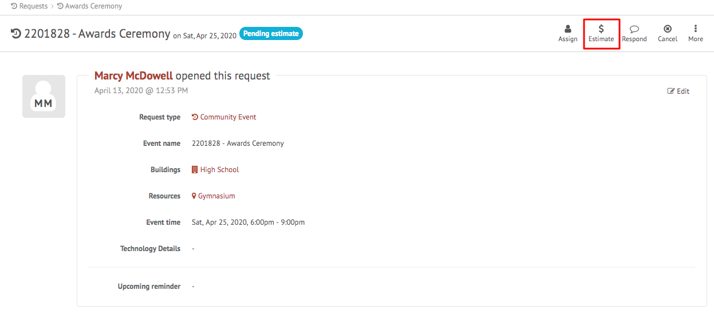

Step 2: Enter the amount of the estimate along with a description of what the estimate includes. New lines can be added by clicking the green “+” arrow.

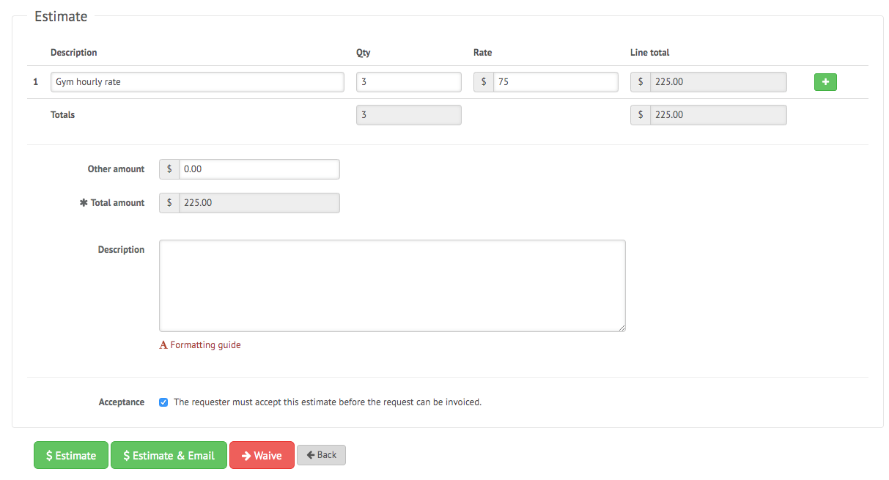

Step 3: Click Estimate to save your estimate. Click Estimate & Email to save your estimate and email a PDF format to the requester. Click Waive to skip this process. If the “Acceptance” checkbox is selected, this will generate an email notification to the requesting user asking them to confirm the estimate.

Invoice a Schedule Request (Skip this portion if you are not responsible for invoicing)

Step 1: Find the schedule request you wish to invoice (on the calendar or in the schedule requests grid), then click Invoice. (Please note that the invoice action only appears once a request has been estimated and the estimate has been accepted by the requesting user.)

Step 2: Enter the invoice amount along with a description of what the final invoice includes. Click Invoice to send your invoice.

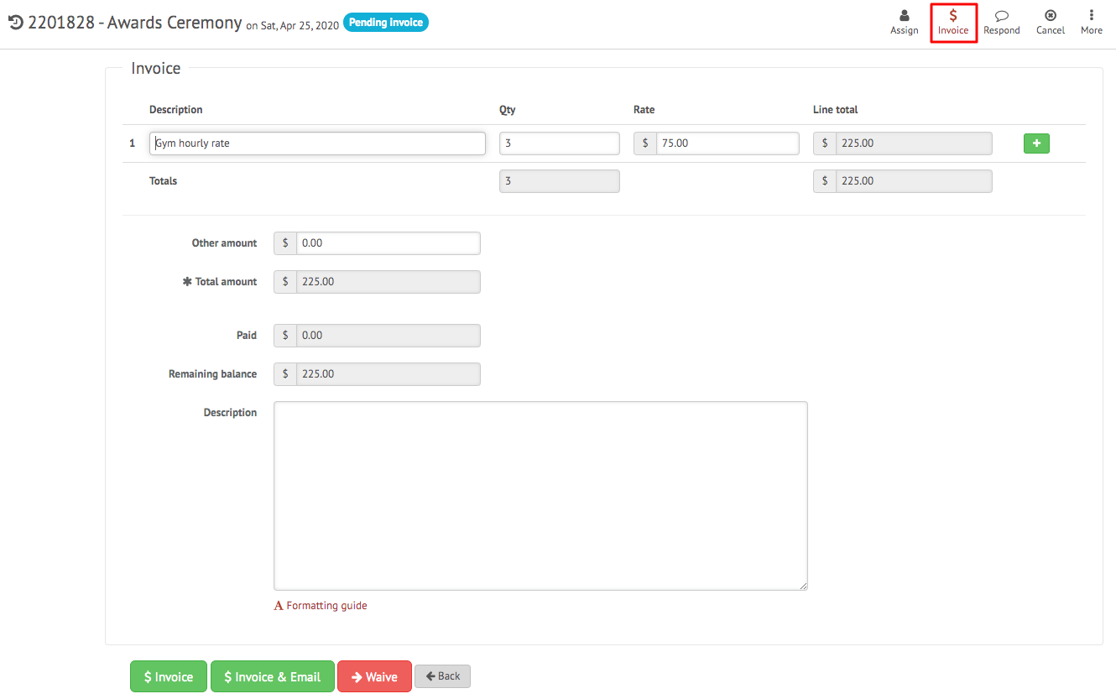

Apply a Payment to a Schedule Request (Skip this portion if you are not responsible for payments)

Step 1: Find the schedule request you wish to apply payment to (on the calendar or in the schedule requests grid), then click Apply Payment. (Please note that the apply payment action only appears once a request has been invoiced.)

Step 2: Enter the payment amount, or click the checkbox for “Remaining balance amount”, and click apply payment.

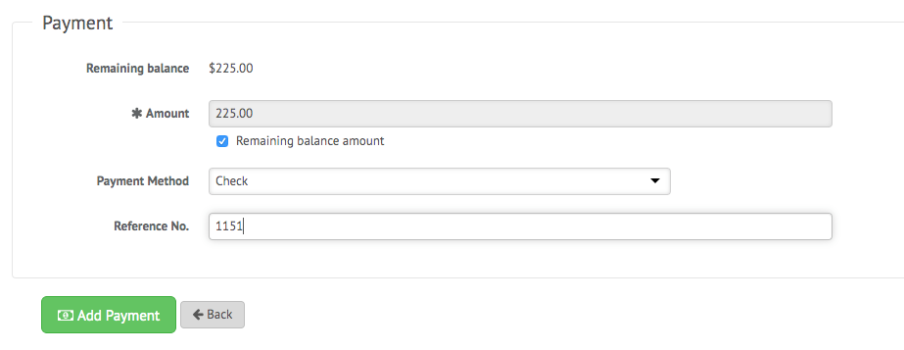
Step 3: To apply additional payments follow steps 1 and 2. Once a request is paid in full it will be flagged as finalized and payments can no longer be added.

Filter in Calendar View
Step 1: Click the Filter button above the calendar view and select the filter you would like:
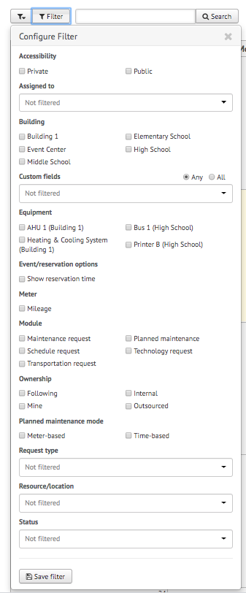
NOTE: You may choose more than one filter at a time
Remove Filters
If you're having trouble locating certain requests, events, or other information on your FMX calendar or in your FMX grids it could be because you have a filter selected that is hiding the information you're looking for.
You can see the filters that have been applied by looking underneath the Filter and Search bar:
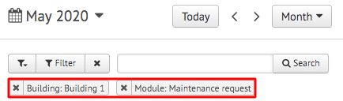

Remove All Filters
To quickly remove all of the filters that are currently selected, click on the "x" attached to the filter button:
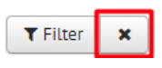

Another way to remove filters is to click on the "Filter" button and choose "Clear Filter" at the bottom of the page:
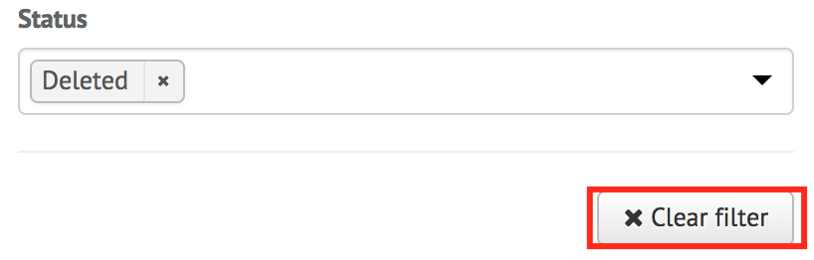

Remove a Single Filter
To remove filters one at a time, click on the "x" button next to the filter(s) you would like to remove:
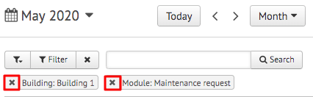

Save Filters
To save your current filters for future use, click the button at the bottom that says "Save Filter":
Then type in the name of this saved filter. Once done, click the checkmark to save:
