(Your Organization) Maintenance Technician and Vendor Planned Maintenance Guide

Login to FMX

Step 1: Open an internet browser and navigate to (yourfmxsite.gofmx.com)
Step 2: Log in with the following credentials:
- Email
- Password

Respond to a Planned Maintenance Task

Step 1: Find the task you wish to respond to (on the calendar or in the planned maintenance grid accessed via the left sidebar), click on the task to open it, then click Respond.

Step 2: Type your response and click Respond.
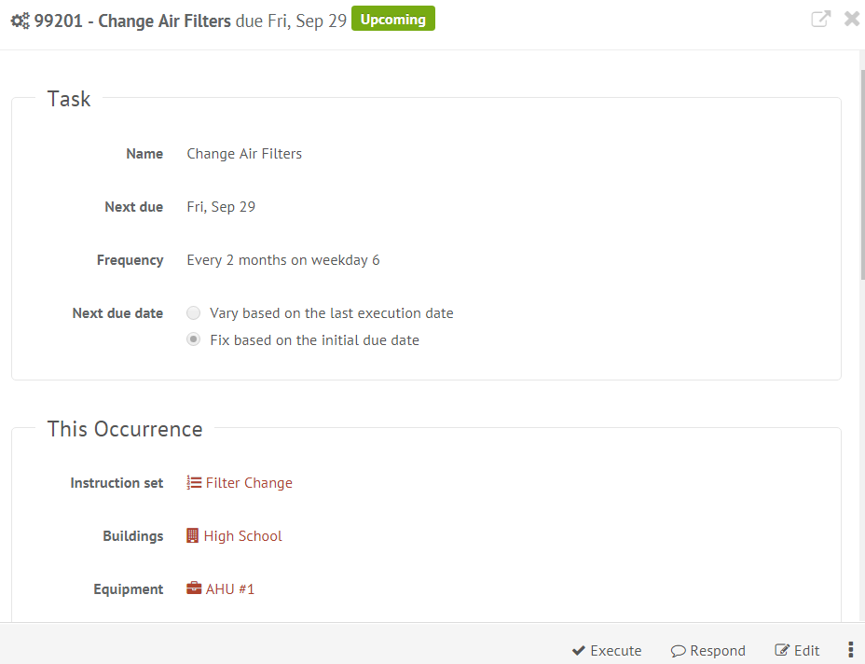

Executing a Planned Maintenance Task

Step 1: Find the task you wish to execute (on the calendar or in the planned maintenance grid accessed via the left sidebar), click on the task to open it, then click Execute.

Step 2: Check off all steps of the instruction set (if there is one), enter a resolution, hours, cost, inventory and attach additional information if necessary.

Step 3: Click Execute to close out the task, or Save to complete the task later.

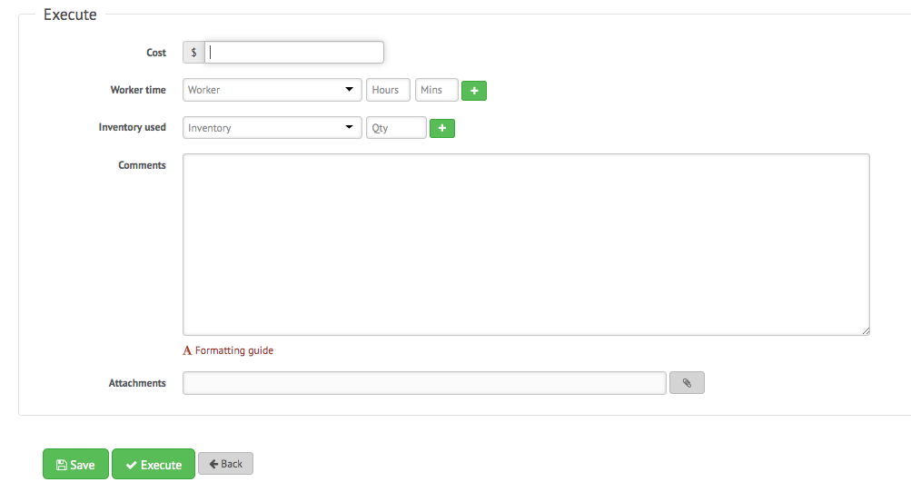

Filter in Calendar View
Step 1: Click the Filter button above the calendar view and select the filter you would like:
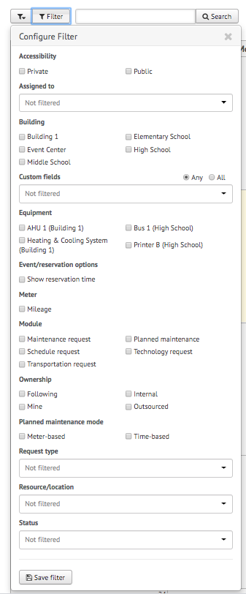
NOTE: You may choose more than one filter at a time
Remove Filters
If you're having trouble locating certain requests, events, or other information on your FMX calendar or in your FMX grids it could be because you have a filter selected that is hiding the information you're looking for.
You can see the filters that have been applied by looking underneath the Filter and Search bar:
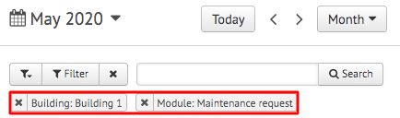

Remove All Filters
To quickly remove all of the filters that are currently selected, click on the "x" attached to the filter button:
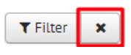

Another way to remove filters is to click on the "Filter" button and choose "Clear Filter" at the bottom of the page:
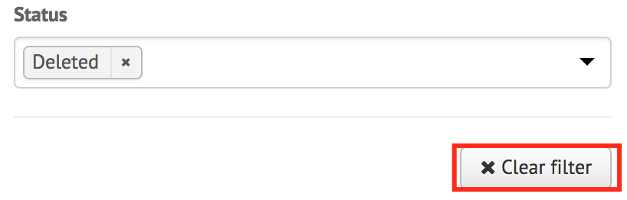

Remove a Single Filter
To remove filters one at a time, click on the "x" button next to the filter(s) you would like to remove:
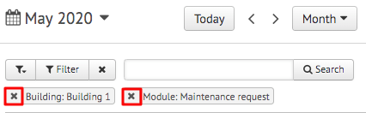

Save Filters
To save your current filters for future use, click the button at the bottom that says "Save Filter":
Then type in the name of this saved filter. Once done, click the checkmark to save:
